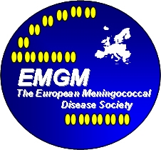 *EMGM* –The European Meningococcal Disease Society

President: Prof Urich Vogel (Germany)

Vice President: Dr Paola Stefanelli (Italy)

Secretary: Dr Georgina Tzanakaki (Greece)

Treasurer: Dr Steve Gray (UK)

*EMGM* web address: [www.emgm.eu](http://www.emgm.eu)

**Membership fee**

In future we will be collecting membership fees for two year periods together in order to minimise administration and bank charging costs.

Members have full voting rights, are entitled to reduced fees for EMGM meeting registration and other benefits

**Fees due** **Amount**

Membership for 2 year period € 100,00

**Method of Payment**

Preferred method is by direct transfer to:

Account Name: EMGM – European meningococcal Disease Society

Bank Name: Erste Bank der österreichischen Sparkassen AG

Address: Obere Hauptstrasse 4

A-7561 Heiligenkreuz im Lafnitztal, Austria

IBAN: AT742011128616128300

BIC: GIBAATWW

**Please be sure to provide your name as a reference if the payment is from an institution account**

**PLEASE KINDLY NOTE that payment by credit card will NOT be accepted.**



Steve Gray

EMGM Treasurer

Tel: +44 (0)161 276 6764

Fax: +44 (0)161 276 5744

E-mail: steve.gray@hpa.org.uk